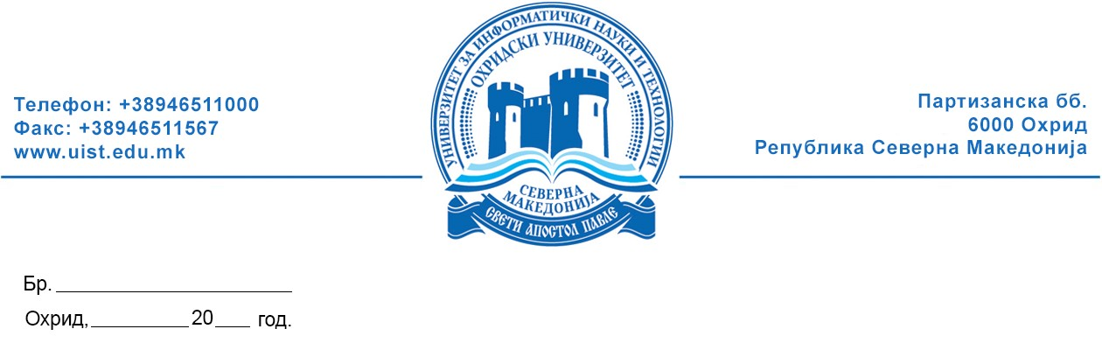

PUBLIC ANNOUNCEMENT
of Elections for Student Assembly Members of the Faculties and President of Student Assembly at the University of Information Science and Technology “St. Paul the Apostle” Ohrid

- All students are hereby informed that on October 30th, 2024 (Wednesday) elections for members and President of:

- The Student Assembly of the Faculty of Communication Networks and Security

- The Faculty Student Assembly is composed of student representatives from all study programs of I and II cycle of studies and consists of 10 (ten) members.
- All students who are enrolled in the 2024/2025 academic year have the right to elect and to be elected as members of the Faculty Student Assembly.
- A full-time student who has passed all exams by the third semester may be elected as President of the Faculty Student Assembly.
- Elected president and members of the Faculty Assembly is/are considered the candidate /candidates who has/have received the most votes from the students of the respective Faculty who voted, if more than 30 % of the total number of registered voters voted for them. Each student votes for 10 candidates from the list of proposed candidates for members of the Faculty Student Assembly.
- A full-time student who has passed all exams by the third semester may be elected as President of the Faculty Student Assembly, if more than 30 % of the total number of voters registered in the voter list voted for him/her.
- Candidates for President and members of the Faculty Student Assembly are determined at the student gatherings for determining candidates for members and president of the Faculty Student Assemblies which will be organized online through Google Forms by the election committees for each Faculty.
- All students interested to be candidates for the Faculty Student Assembly or President of the Faculty Student Assembly are invited, after holding the student gatherings organized by the Election Committee of the faculty, which will be held no later than October 26th, 2024, to submit an application for a candidate for election of president and member of the Faculty Student Assembly to the Election Committee.
- The voting will take place on October 30th, 2024, in the UIST Classroom 6 from 11 AM to 1 PM.
- The public announcement is posted on the UIST Bulletin Board and on the official UIST Ohrid website.

Election Committee:

1. Assoc. Prof. Aneta Velkoska – President

2. Asst. Prof. Jovan Karamachoski – Member

3. Ebru Cico– Student – Member

4. Ilija Meckaroski – Student – Member

5. Stefan Trajanoski – Student – Member

